# GIT COMMANDS

git clone <url> --to download git repository from git hub to local computer

git status -- to get status

git add . -- to add everything in staging area

git checkout <branchname> -- to change branch

git branch <branchname> -- to create branch from current branch

# BROWER SYNC

browser sync lets u see changes in browser immediately after u safe ur html/css file.

(although i have to reload it in browser .. prof was immediately seeing changes in browser as he was saving html file.)

# stackoverflow

Website to ask doubts with people.

# jsfiddle.net

This website can be used to share a runnable code with people , where they can see the code and output in order to help.

Just copy the url and share after writing code. People can use that url to view code and its output.

They can fork it, so they can make changes to ur code and u can compare the code.

# Codepen.io

Used same as jsfiddle.net

# css-tricks.com

Resourse website , can be used for reference.

Hypertext : text that contains link to another text

hypermedia is also there

markup : to mark something up.

Like: <title>why i love this course</title>

above text is marked up by <title> tag.

Html is a **language** : as there is syntax for it. U can code according to that syntax.

# 3 CORE WEB TECHNOLOGIES:

**HTML** : used for structuring.

Like if there is title,footer,header, how many paragraphs.

**CSS** : used for styling.

**JAVASCRIPT**: used to define behaviour of a webpage/site.

Like what happens if i click one of the headings etc

what happens to the page once it is loaded in browser.

**SEO** : Stands for search engine optimization.

**<div> tag** is a block element. It renders the content in a new line (content before and after this tag is in new line).

**<span> tag** is an inline element. Content written between this tag is rendered on the same line by the web browser.

**<p></p>** paragraph tag: puts the contents in paragraphs.

<**section></section>** : section tag.

**If we want to include html tags as content in a webpage:(html entity reference)**

**Instead of: use:**

1. < &lt; (stands for less than)

2. > &gt; (stands for greater than)

3. & &amp; (amp stands for ampersand)

*Never use the above 3 characters as such, instead use (&lt; , etc.)

4. for copyright symbol use : **&copy;**

5. if we want some words to appear always together in one line irrespective of window size, we use

non-breaking space : **&nbsp;**

example: victory**&nbsp;**nor**&nbsp;**defeat.

Hyperlinks:

**<a href=”link” target=”_blank” title = “takes to link.com”>**

*click here*

**</a>**

***target=”_blank”*** in <a> tag will open the link in new tab rather than on the same tab.

Various tag IDs can be used to navigate within the page like in wikipedia.

Eg-

navigation

<a href=”#section1”>Go to section1</a>

...

...

<section id=”section1”>

abcd...

...

...

</section>

**Comments in html:**

<!--your comment-->

**Image tag:**

<img src=”URL/link” alt=”text to be displayed if image not loaded”

width=”dimension” height=”dimension”>

***CASCADING STYLE SHEETS: (CSS)***

It determines how the user will experience ur content.

**Anatomy of a CSS Rule:**

***selector (a tag) {***

***property : value;***

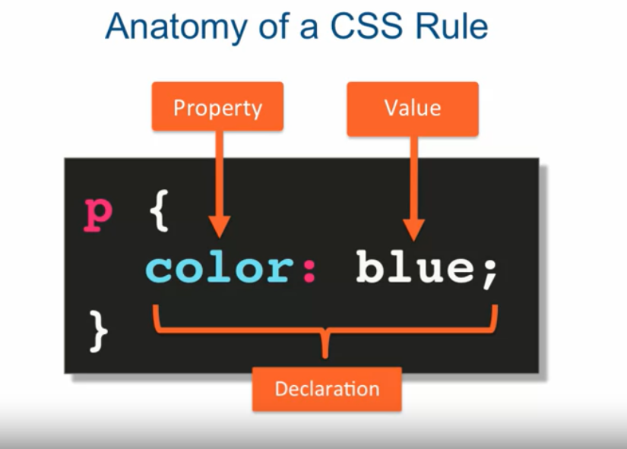 ***}***

***Eg:*** *p {*

*color: blue;*

*}*

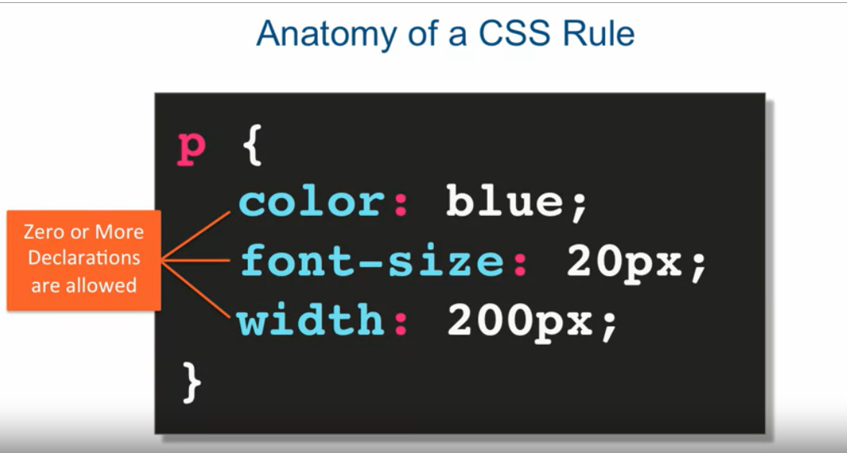

*\* Collection of CSS Rules is known as Style Sheet.*

*Style Sheet written within <style></style> tag.*

***Selectors in CSS:***

*Selectors define which elements in the webpage to apply CSS rules.*

**1.Element Selector:**

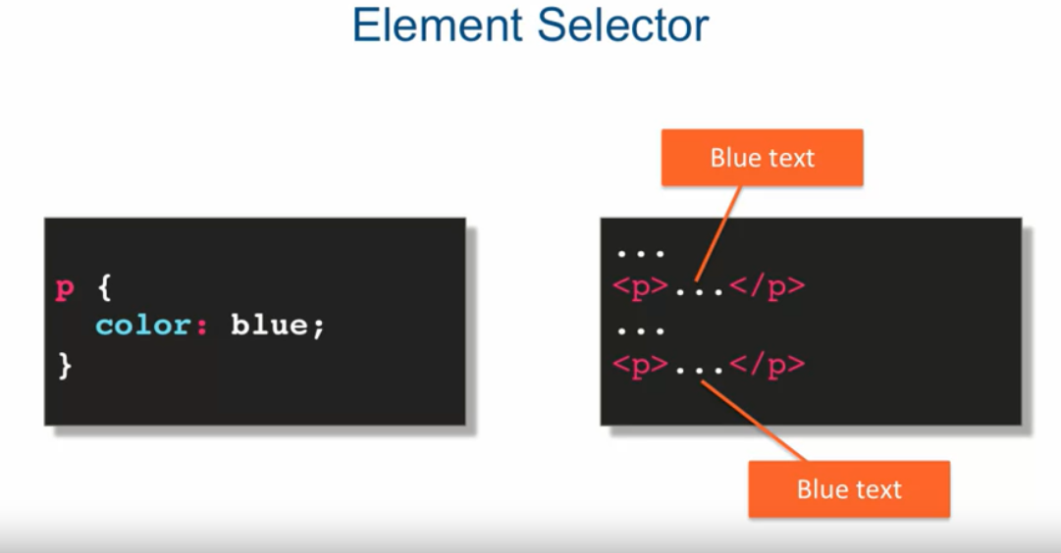

**2.class Selector:**

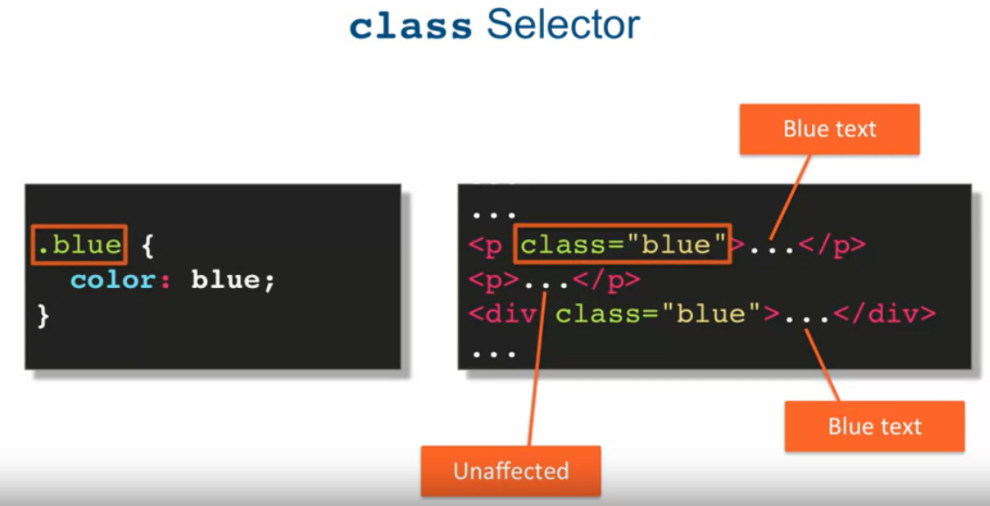

*\*defined with . but used without .*

**3. id Selector:**

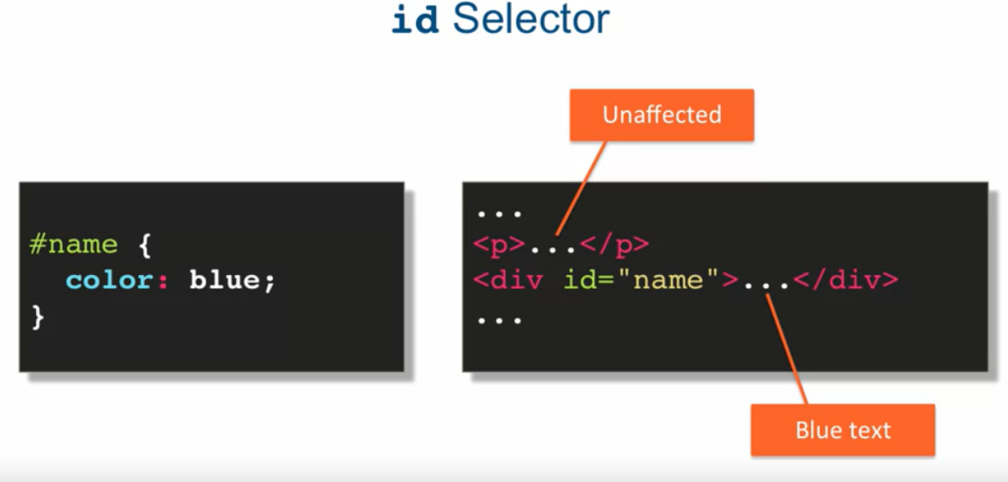

Defined with #(pound), but used without #.(just like navigation in same page using hyperlinks.)

*less efficient as we have to define id for each element(id is unique for every element).

**Grouping Selectors:**

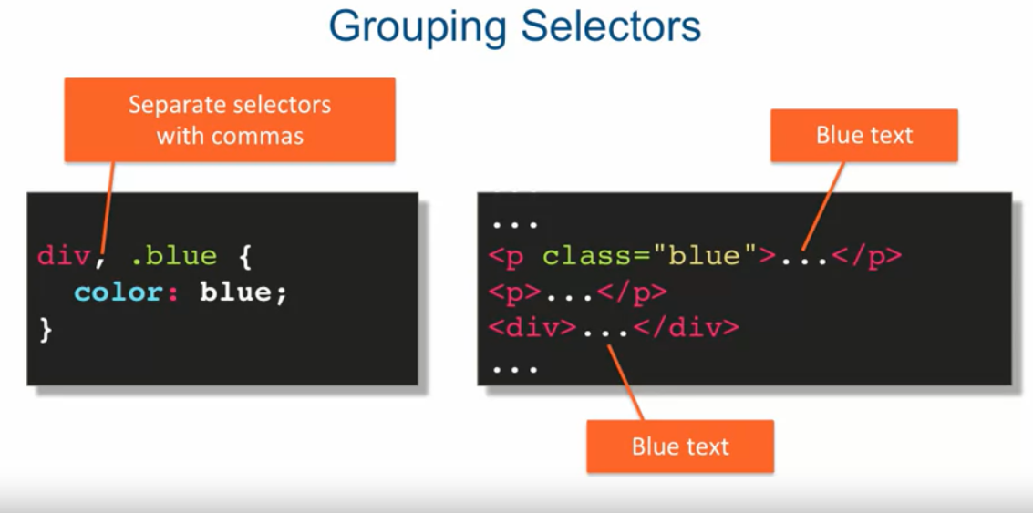

***Combining Selectors:***

***1.Element with Class Selector:***

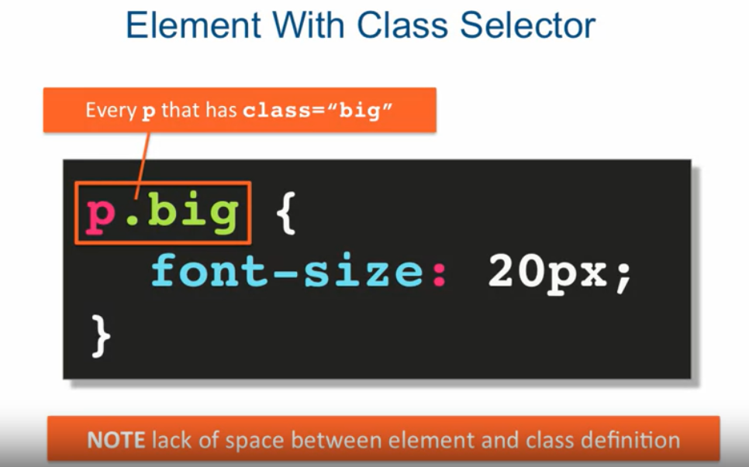

Only the defined element having define class will get affected rather than all elements of that class.

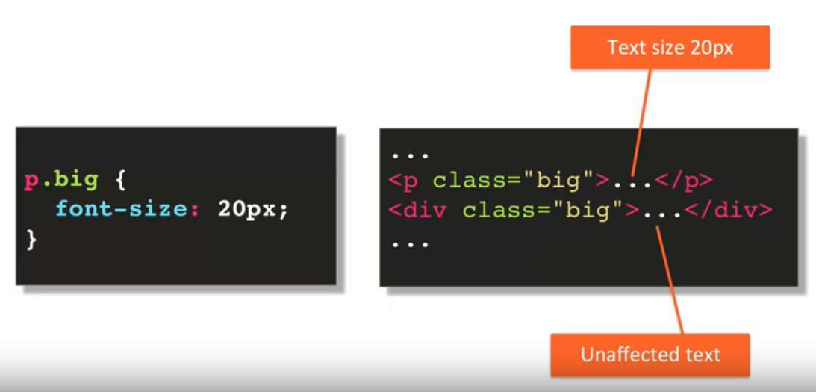

**2.Child Selector:**

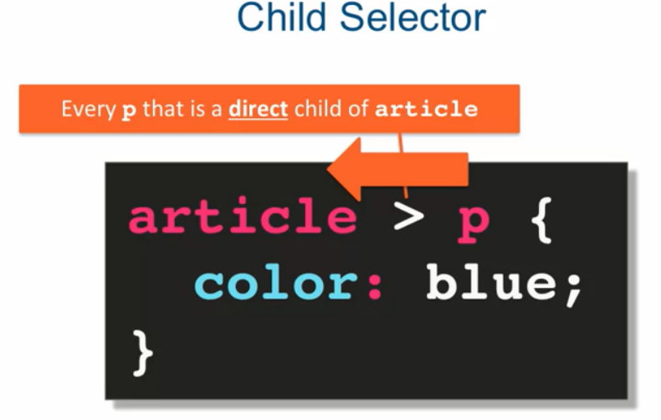

**\****Only direct child element will get the styling.*

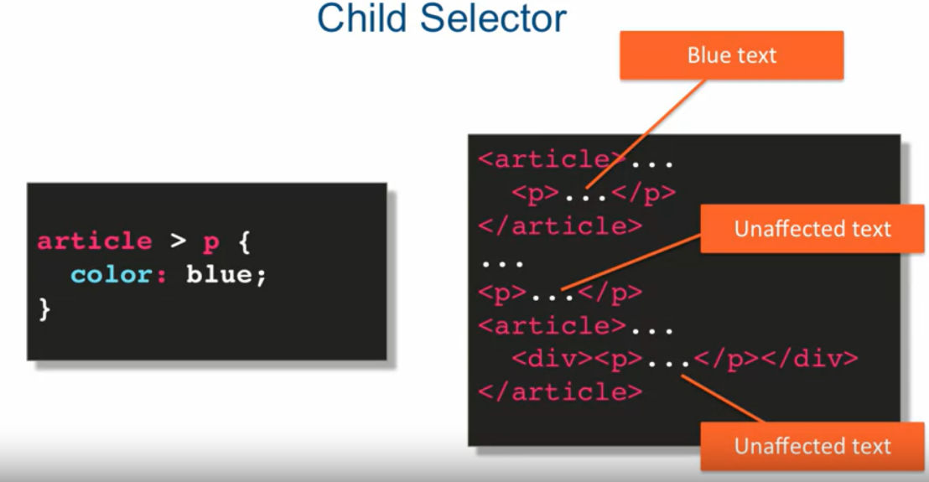

*3.****Descendant Selector:***

***\*****All child at all levels will get affected.*

*Extented version of child selector.*

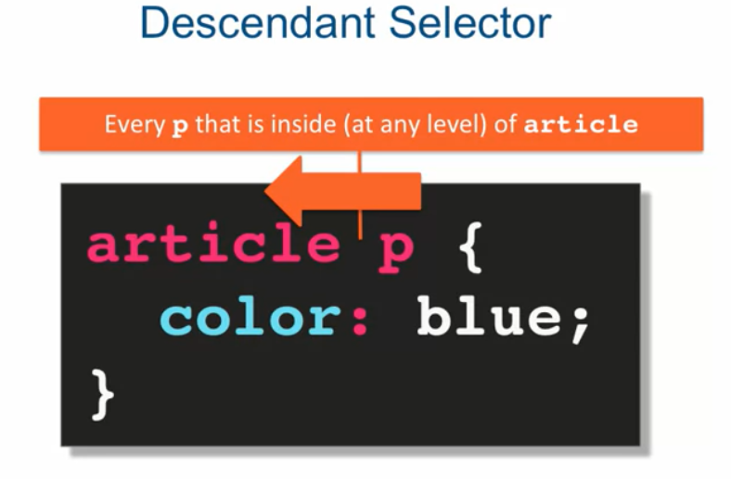

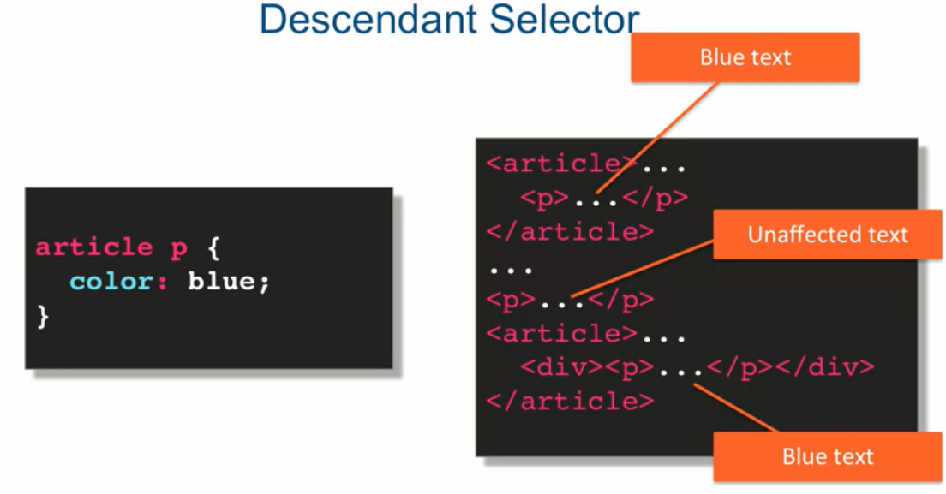

External style sheets are used to maintain consistent styles across all webpages.

Head styles used to override external style sheets.

Inline styles only good for testing purpose.

***PSEUDO CLASS SELECTORS :***

These selectors give the ability to style an element based on user interaction, Eg. We can change style of element when user hovers cursor over it , when the user has clicked an hyperlink, etc.

Some of the pseudo-class Selectors are :

:link

:visited

:hover

:active

:nth-child(...)

-> Styling links is not as state forward as styling other elements because links have states( eg, visited,active,hover,etc). These states can be expressed as pseudo classes.

Visited state – when the user has visited the link.

Link state – when user has not visited the link.

Hover state- when the user hovers cursor over the link.

Active state- when the user has clicked the link but has not released the click.

:nth-child(...) selector in its simplest form gives the ability to target a particular element in a list.

Examples:

1). a:link, a:visited {

text-decoration: none;

background-color: green;

border: 1px solid blue;

color: black;

display: block;

width: 200px;

text-align: center;

margin-bottom: 1px;

}

in above example both visited and unvisited links are styled same.

2).

a:hover, a:active {

background-color: red;

color: purple;

}

<!--in this example same style applied to links when user hovers and clicks on links -->

3).

header li:nth-child(3) {

font-size: 24px;

}

<!-- in this example 3rd list item inside the header is stylized-->

4).

section div:nth-child(odd) {

background-color: gray;

}

<!-- in this example every div element at odd position inside section tag is stylized-->

#Pseudo class selectors can also be combined like other selectors like

5).

section div:nth-child(4):hover {

background-color: green;

cursor: pointer;

}

<!--when a user hovers over 4th div element inside secton tag it is stylized-->

**Always make sure your selectors are readable.(for others, as it can become maintenance nightmare).

Simple/Readable is always better than Complicated/Tricky.

***Style Placement***

CSS styles can be placed at different places which not only decides reusabilty of the rule but also decides which rules will override others.

1).Rules can be placed inside the <head> tag :

<head>

<meta charset="utf-8">

<title>Style Placement</title>

<style>

h2 {

color: maroon;

}

</style>

</head>

<--In this way of placing CSS styles , it will only affect the element inside this webpage. Styles will not apply to other pages-->

2).Directly on the element:

<p style="text-align: center;">

I am centered!

</p>

<!--This is the least reusable way of placing CSS style as it only affects the element on which it is placed-->

3).External Style Sheets: It is just a file saved with .css extension which contains CSS rules/styles.(Need not contain <style> tag)

To link the external style sheet to html pages we just have to include link tag in html pages.

<head>

<meta charset="utf-8">

<title>Style Placement</title>

<link rel="stylesheet" href="style.css">

</head>

<!--Here “style.css” is the name of external style sheet located in same folder in which html page is present, because relative url is given on href-->

<!--It is the most reusable way of placing styles as it can stylize every html page to which it is linked. -->

**In real world websites we almost always place CSS styles as external style sheets, is most reusable, provides consistent styles accross all webpages.

**try to avoid using inline styles(use only for testing purpose).

**Head styles are usually there to override external styling. But is questionable.

***Conflict Resolution In CSS:***

1).***Origin Rule:***

When there are several rules affecting the same property of a particular element, conflict arises i.e. which rule will apply and win, then

*origin precedence comes into picture

“Last Declaration Wins.”

*Remember, HTML is processed Sequentially i.e. top to bottom.

2).***Merge Rule:***

>When several rules affect different-different properties of same element , then there is no conflict and “Declations Merge”.

Eg. see origin.html in lecture 17.

3). **Property of Inheritence:**

If we specify a style for an element all the children of stylized element will also get stylized.

Children means all the elements written inside of parent element.

Eg. : <body>

<p>

this element is child of &lt body &gt tag.

<div>

this element is child of &lt p &gt tag.

</div>

</p>

</body>

***4). Specificity Rule:***

*“Most Specific Selector Combination Wins.”*

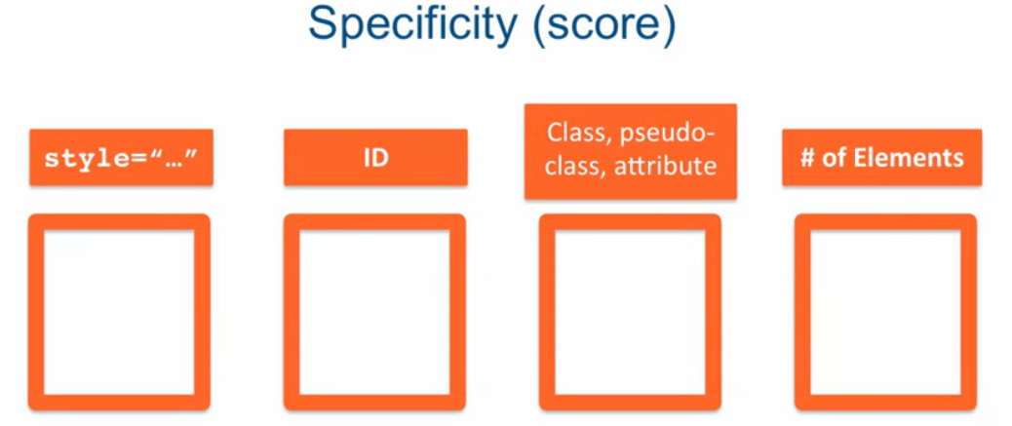 We can think Specificity of a selector as keeping a score , with following decimal places:

i.e. the decimal places are :

inline (thousands), ID (hundrends), Class/Pseudo class (tens),No. Of elements(ones).

“*The selector with the highest score WINS.*”

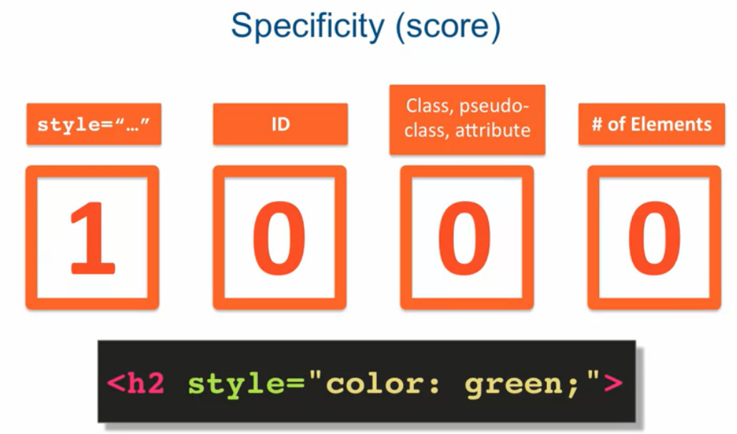Eg.1).

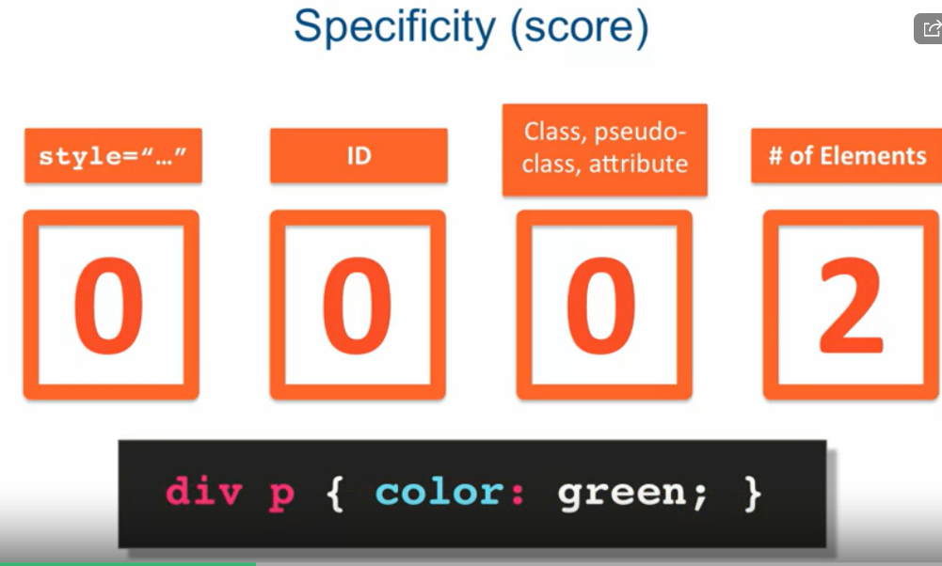2).

3). What will be the colour of the paragraph?

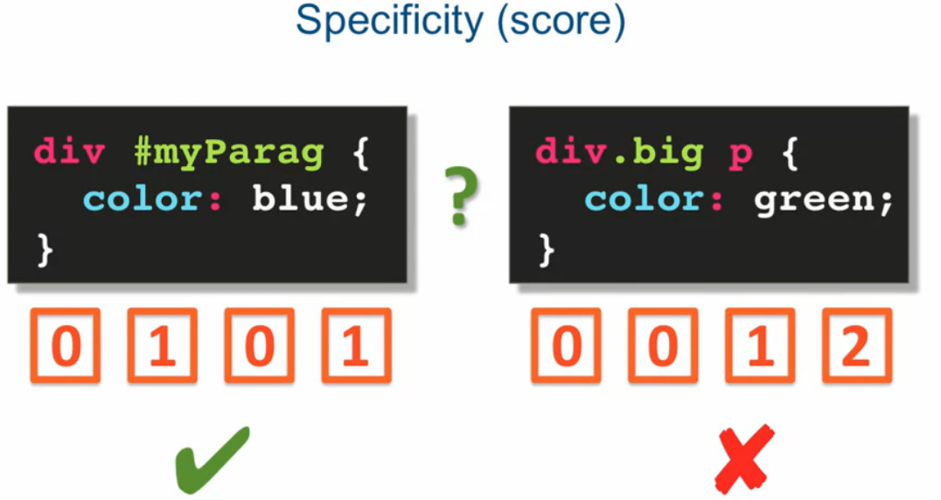In the above example the left selector wins as it has an higher specificity score, and colour of the paragraph will be blue.

4).

header.navigation p { <!--Specificity score is 12-->

color: blue;

}

p.blurb { <!--Specificity score is 11-->

color: red;

}

<!--The colour of the text will be blue-->

5).

#Specificity rule can be overridden by using “!important” in rule:

header.navigation p { <!--Specificity score is 12-->

color: blue;

}

p.blurb { <!--Specificity score is 11-->

color: red;

}

p { <!--Specificity score is 1-->

color: green !important;

}

<!--The last CSS rule wins despite having least score .i.e. 1, as it contains “!important”-->

**WARNING: Using !important and overriding rules will quickly become a maintenance nightmare in real world projects. **So avoid using !important unless you necessarily have to.**

***Styling Text***

There are lot of CSS properties that can be applied to text.

Some of the CSS properties are :

1). font-family: We can specify several font for the text, so that in case a particular font is not present in client’s computer, other specified fonts will be applied.

http://www.w3schools.com/cssref/css_websafe_fonts.asp

*serif means there are small edges at the tips of letters.

Sans-serif means no edges at the tips of letters.(sans means without)

eg: font-family: Arial, Helvetica, sans-serif;

2). color: for real world websites a hexadecimal 6 digit value (colour ID) is used to specify color. (in order #RRGGBB)

Eg. for blue we will use,

color: #0000ff;

3). font-style: we can specify if we want italic text or normal.

Eg.

font-style: italic;

4). font-weight: we can specify whether we want bold or normal text.

Eg. i). font-weight: 900;

ii). font-weight: bold;

5). font-size: as the name suggest it determines how big will be the text.

Pixels(px) is the unit. Default browser size is 16px.

Eg. font-size: 24px;

6). text-transform: we can make text lower case, uppercase, capitalize(1st alphabet of each word is capital),etc,.

Eg. text-transform: uppercase;

7). text-align: using this property we can control whether the text should be left justified, right justified, or centered, etc,.

Eg. text-align: right; <!--text is right justified-->

.style {

font-family: Arial, Helvetica, sans-serif;

color: #0000ff;

font-style: italic;

font-weight: bold;

font-size: 24px; /* points (pt) are used in print, not screen.*/

text-transform: uppercase;

text-align: right;

}

***Relative Font-Sizing:*** There are 2 units of font sizing, (i). % ,(ii). em.

Eg.

1). body {

font-size: 120%;

}

<!--font size will become 120% of default font size (16px) in this case-->

2).

body{

font-size:2em; <!--2em=200%, 120%=1.2em-->

}

<!--font size will become *twice* of font size of em at that moment(its relative)-->

*In case of relative font sizing there is no overriding in fact relative font sizing rules will give their combined added output (in case of parent child elements).

**Do not mix %, em, and absolute font sizing as it will be confusing and will become a mess. **Better to keep things consistent.**

**Professor Yaakov’s website for reference:(must check when needed its good)**

**https://clearlydecoded.com/**

***The Box Model***

In HTML each element is considered a box, however there more to that box than just the content it wraps around.

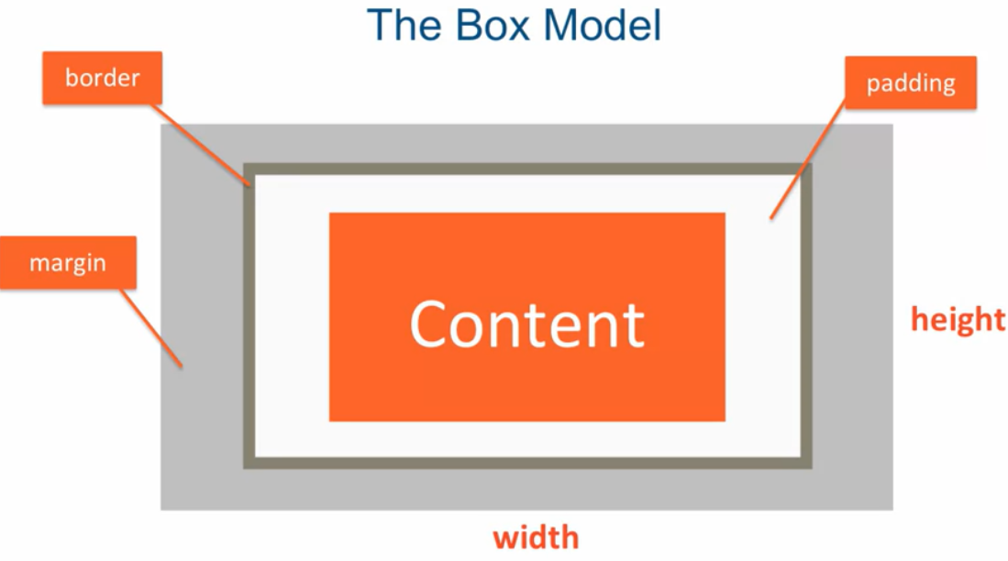

There is also padding, border ,margin width and height in addition to content for an element in HTML.

- 8px default magin is given to body by browser.

We can reset the browser default style:

body {

margin = 0;

padding = 0;

}

-By default when we set width of the box, it is actually width of content only(not including padding,border and margin).

-When we set

box-sizing: border-box; // by default it is content-box;

Then the width property will become the actual widht of the box, including conten, padding, border and margin.

*Always choose box sizing as “border-box” while working with layouts.

Ex:

<head>

<style>

#box {

background-color: blue;

padding: 10px; // or 10px 10px 10px 10px ; (i.e. for //top,right,bottom,left repectively

border: 5px solid black;

width: 300px;

height: 50px;

margin-top: 50px;

}

#content {

background-color: #90EE90; /* green */

}

</style>

</head>

<body>

<div id="box">

<div id="content">Content here!!!

</div>

</div>

</body>

\***box-sizing is of those CSS properties that is not Inherited.**

So we have the concept of star(*) selector.

***Star selector/Universal selector :*** It is represented as ‘*’.

It says that go ahead and apply the property to all elements.(Not inherit , apply to all ).

Eg:

* {

box-sizing: border-box;

margin: 0;

padding: 0;

}

Resetting browser defaults can be done using ‘*’ selector.

***\* caniuse.com*** : *Its a website that can be used to check whether all browsers support a paricular property(like border-box).*

***Cumulative Margins:***

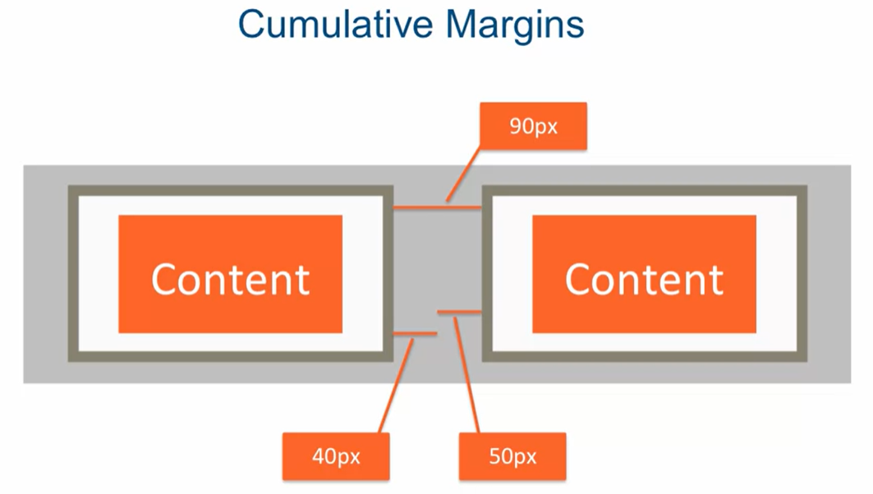When 2 elements are next to each other (left and right) their margins add up.

However, when the elements are up and down each other (next to each other vertically) , instead of adding up of margins , only larger is applied.(margin collapse and Larger margin wins).

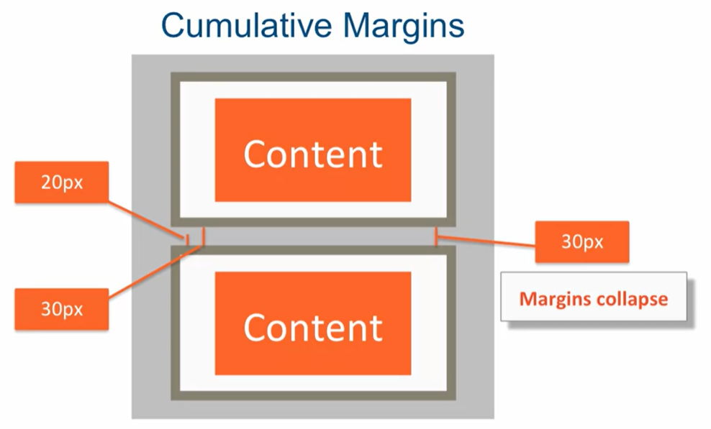

***Overflow Property:***

When the content size is more than the specified box size(i.e width and height), content *overflows* the box.

Eg:

#box {

background-color: blue;

padding: 10px;

border: 5px solid black;

width: 300px;

height: 50px;

margin-top: 50px;

}

#content {

background-color: #90EE90; /* green */

}

<div id="box">

<div id="content">Lorem ipsum dolor sit amet, consectetur adipisicing elit. Suscipit error quis ab perspiciatis eos inventore recusandae iste itaque numquam facilis, tenetur. Doloribus officiis quae facilis, nisi, ex similique. Animi, perferendis.

</div>

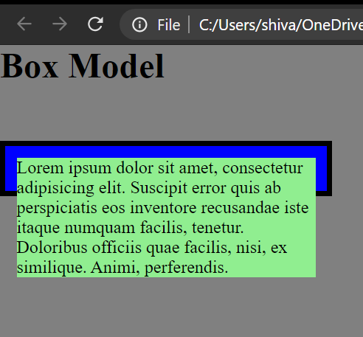</div>

Where as we can specify *overflow : auto; (it will add scroll bar wherever its needed.)*

#box {

background-color: blue;

padding: 10px;

border: 5px solid black;

width: 300px;

height: 50px;

margin-top: 50px;

***overflow: auto;*** *// by default its* ***overflow: visible;***

}

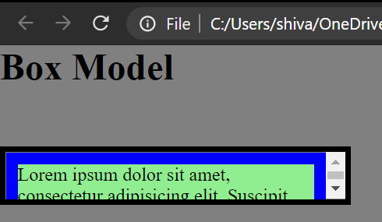

- overflow: scroll; will just add scroll bar whether its needed or not.

\*\**Users don’t like to scroll inside element in a webpage , however its perfectly normal and expected to do in some cases like while reading terms and conditions.*

*Q.*1.

Question 1

Assuming no other styles exist, how many pixels wide will the 'div' tag be with the following styles:

div {

padding: 10px 10px 10px 10px;

margin: 10px 10px 10px 10px;

width: 100px;

border: 10px solid black;

}

***Ans:*** 100px width + padding of (10px left + 10px right) + border of (10px left + 10px right) = 140px. ***Margins don't define the width of the box. Just define how far other elements should be pushed away from it.***

***The Background Property***

Background property has many sub-properties: color, image, position, etc,.

**background-color:** sub property to specify background color.

Eg. background-color: blue;

**background-image:** We can put an image as a background using this property.

Eg. background-image: url(“yaakov.png”);

//yakov.png is a relative url, it has to be relative to the way CSS is served to the browser.

**background-position:** We can specify the position of image in the background.

Eg. background-position: bottom right; // by default top right

**background-repeat:** We can specify whether to repeat background image vertically, horizontally or not repeat at all. (by default it repeats both horizontally and vertically)

Eg. background-repeat: no-repeat;

\****Image wins in terms of priority and will be on top of background-color.***

***All these background properties(subproperties) can be combined as:***

*background: url('yaakov.png') no-repeat top center blue;*

*\*\*If we write combined properties as “background:” as in above example it will override all the individual subproperties define before it.(****subproperties defined after will NOT be overriden****) .*

***Positioning Elements by Floating***

*-*When we float elements the browser takes them out of the regular document flow.

*-*Margins(vertical) never collapse in case of floating elements.

-When floating elements don’t fit in a single line the jump to the next line.

***clear: Property*** : It tells the browser that there should not be a floating element in the specified direction.

Eg. *1). clear: left; //* nothing should be floating to the left.

2). *clear: both; //*nothing should be floating to left and right.

3). section {  
 clear: right;  
 }

//says that none of the section elements should allow anything to float to the right of them.

***Two Column Layout Design:***

-> Set box-sizing: border-box;

-> For the column elements, set their width to 50% (relative sizing)of the containing parent element.

In case of block level elements like <div> they take up the whole horizontal space, so if a child <p> element is has width 50%, it will occupy exactly half of the horizontal space irrespective of the browser window size.

->Make both the column elements to float left, they will make up flexible columns.

Eg.

<style>

* {

box-sizing: border-box;

}

p {

width: 50%; // 50% of parent element , in this case <div>

float: left;

padding: 10px;

}

section {

clear: left;

}

</style>

</head>

<body>

<h1>Two Column Design</h1>

<div>

<p id="p1">Lorem ipsum dolor sit amet, consectetur adipisicing elit. Quia distinctio aliquid cupiditate perferendis fuga, sit quasi alias vero sunt non, ratione earum dolores nihil! Consequuntur pariatur totam incidunt soluta expedita.</p>

<p id="p2">Lorem ipsum dolor sit amet, consectetur adipisicing elit. Dicta beatae voluptatibus veniam placeat iure unde assumenda porro neque voluptate esse sit magnam facilis labore odit, provident a ea! Nulla, minima.Lorem ipsum dolor sit amet, consectetur adipisicing elit. Eius nemo vitae, cupiditate odio magnam reprehenderit esse eum reiciendis repellendus incidunt sequi! Autem, laudantium, accusamus. Doloribus tempora alias minima laborum, provident!</p>

<section>This is regular content continuing after the the paragraph boxes.</section>

</div>

</body>

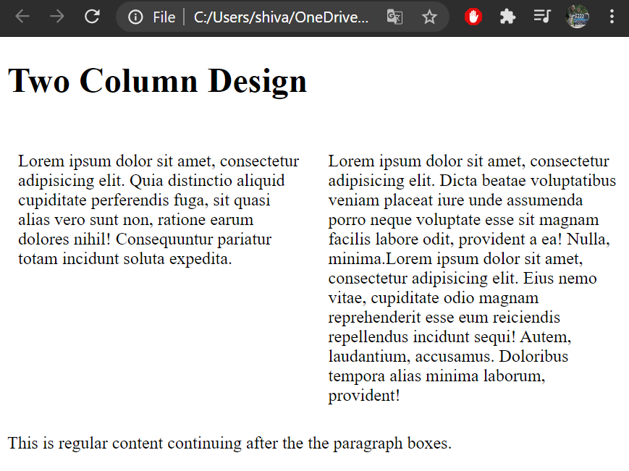

**Summary**

*Floating elements can produce very flexible layouts.

*Floats are taken out of the regular document flow.

*Floats don’t have vertical margin collapse.

*To resume normal document flow, use the **clear** property.

***Relative and Absolute Element Positioning***

**Static positioning**: It is another way of saying normal document flow.

Its default for all element except <html> element.(tag)

**Positioning CSS (offset) properties are:**

**top,bottom,left,right.**

**\*\*Positioning offsets are ignored if positioning is static**(which it is by default).

**Relative Positioning:**

Element is positioned relative to its position in normal document flow.

Element is NOT taken out of document flow, even if its moved its spot is preserved.

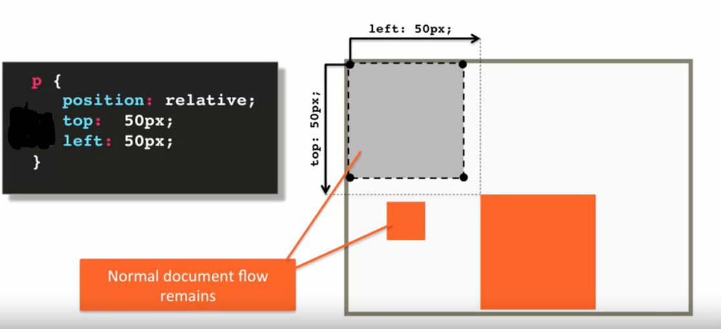

As represented in above example the properties can be thought as “from top” and “from left”.

It can also be written as “bottom: -50px;” and “right: -50px;”

**Absolute Positioning:**

*All offsets (top,bottom,left,right) are relative to the position of the nearest ancestor which has positioning set on it, other than static (relative or absolute).*

*->By default , <html >is the only element that has non-static positioning set on it (relative).*

\***Element is taken out of normal document flow if positioning is set to *absolute.***

Eg. consider the elements as follows:

Here the parent element has positioning set to relative.

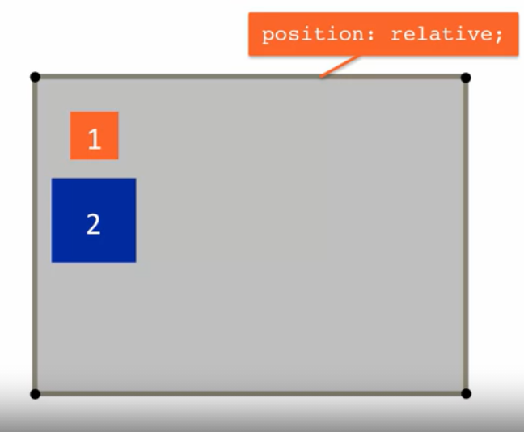

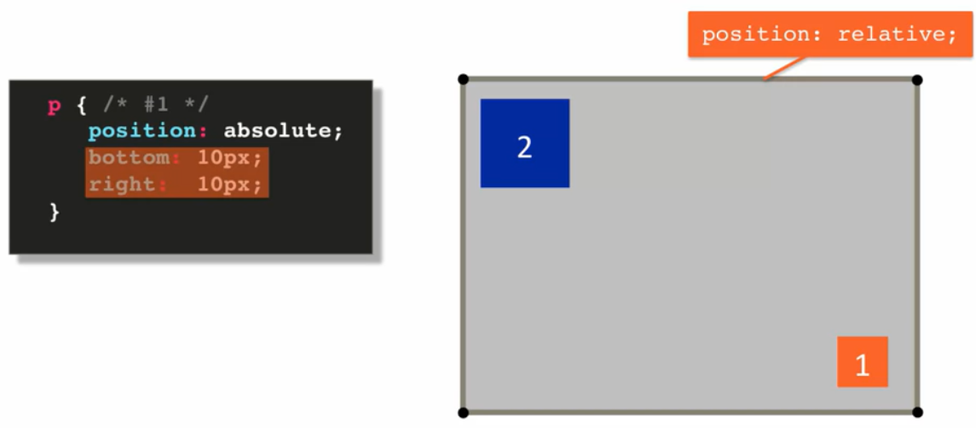If we apply absolute positioning to element 1 , the result will be as follows:

***\*A really cool feature is, if the parent element is offset, everything inside is offset with it.****Which gives flexibility to move a set of elements, not just one.*

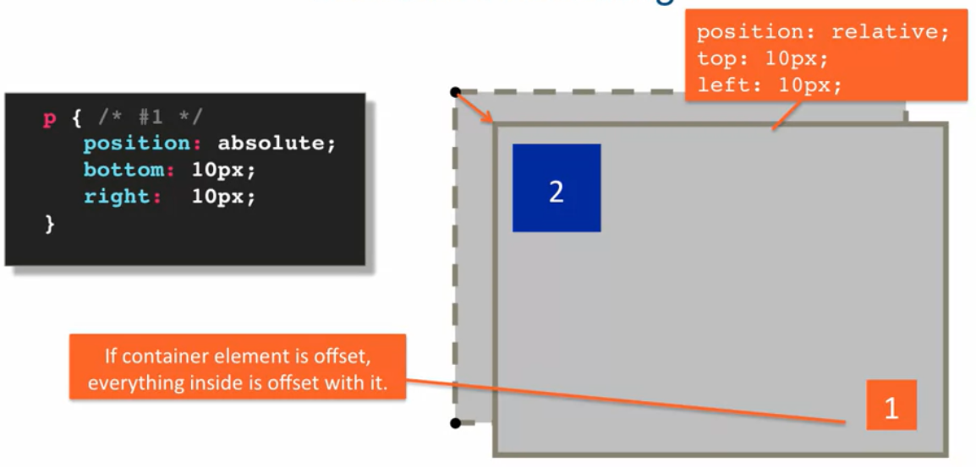(*child element need not be absolute or relative*)

**Media Quries**

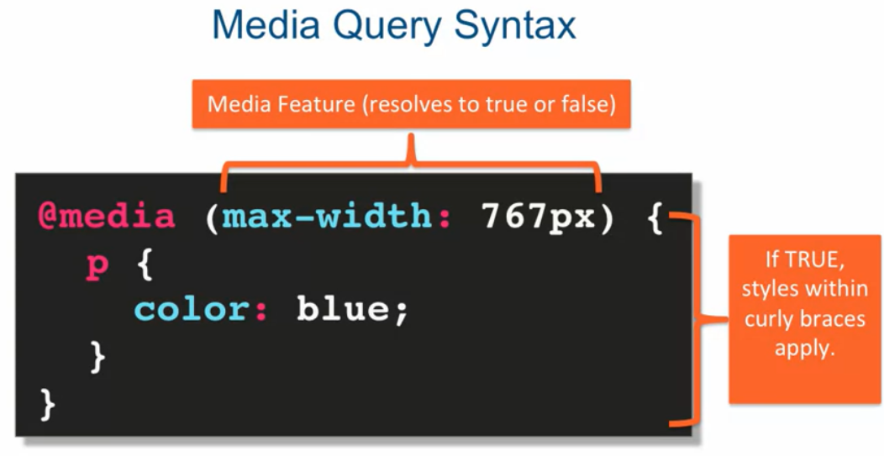One of the applications of media queries is that it allows different styling or layouts based on screen size or orientation.

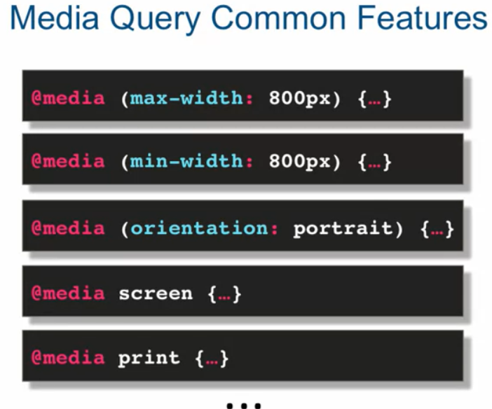

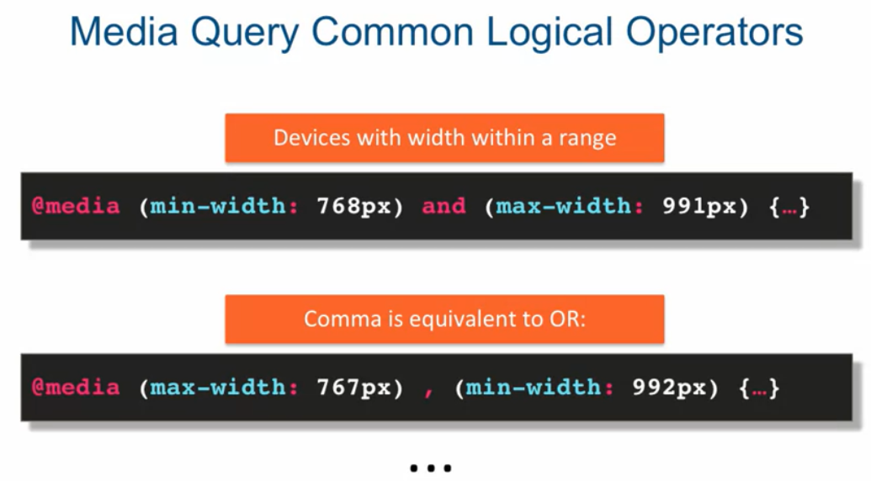Logical operators in media queries:

Common approach is to set base styles(normal CSS styles) and then write media queries:

The usual approach to using media queries is to provide some base styling and then change and/or add to them within each media query.

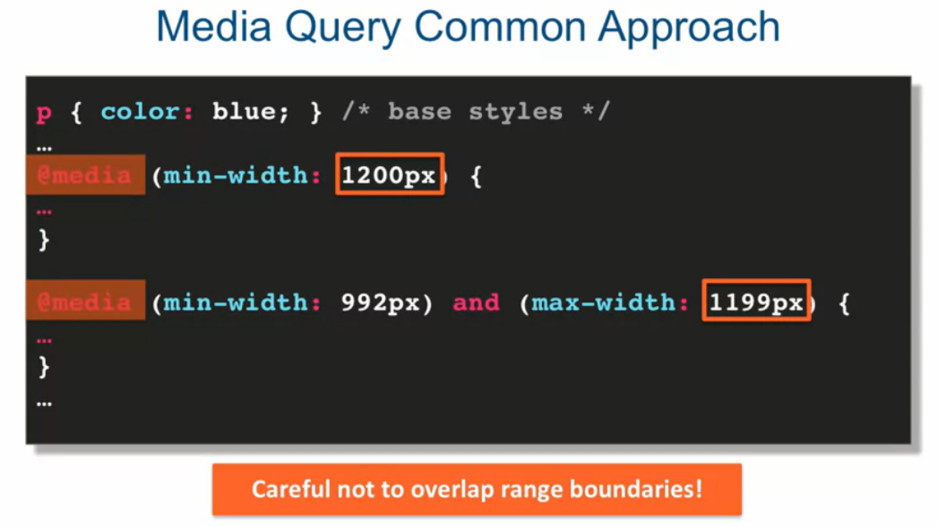\****Careful not to overlap ranges for different media queries.***

End points of range are known as breakpoints.

**Responsive Design**

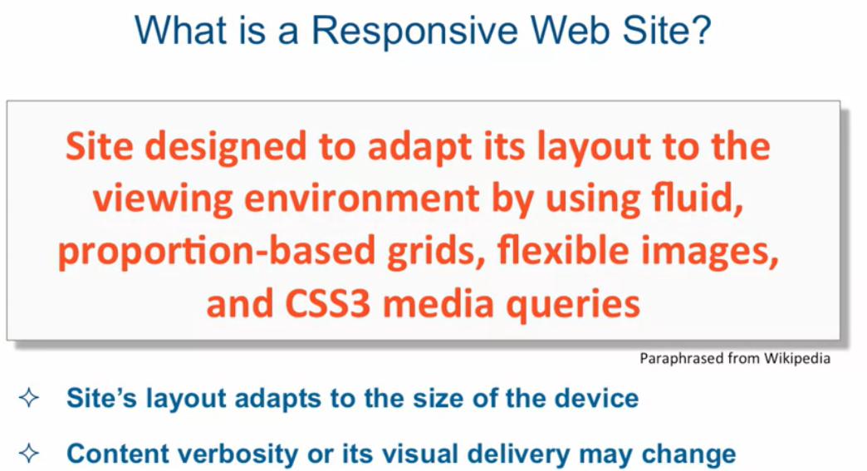

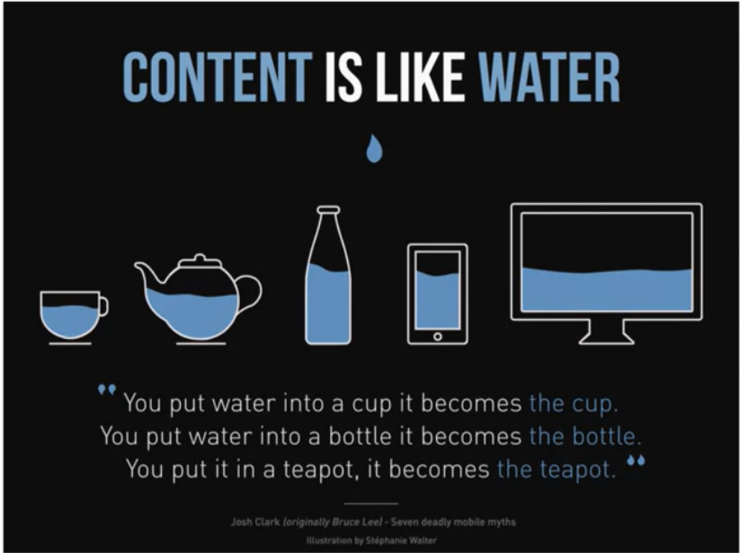

**Most common and most convenient** grid layout for responsive design is 12-Column Grid Responsive Layout. It is also used by twitter bootstrap.

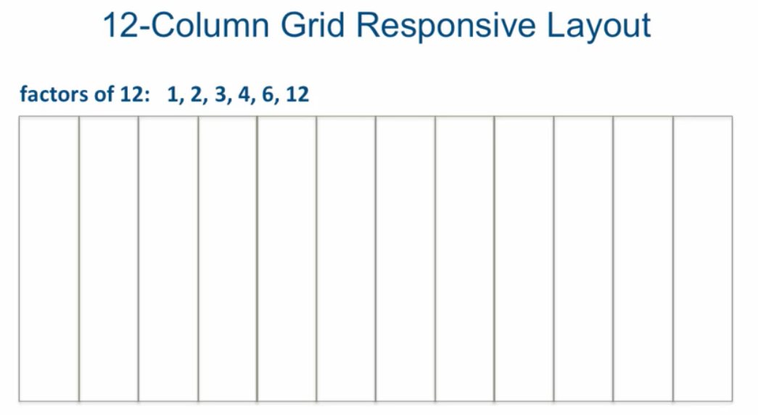

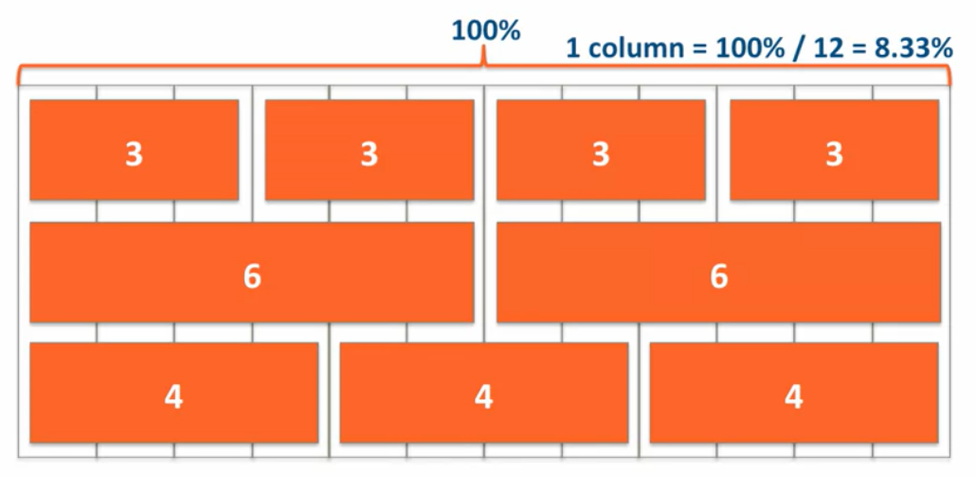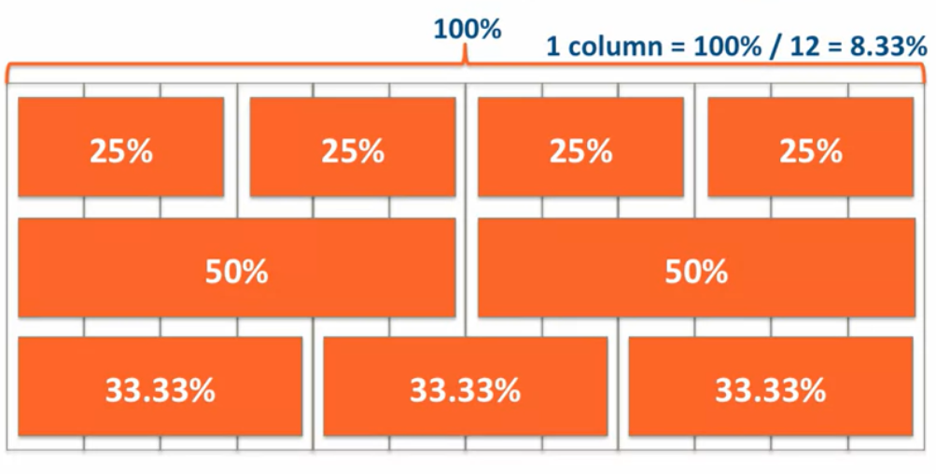

We use % to achieve fluid width (w.r.t. browser width)

There can also be nested grids:

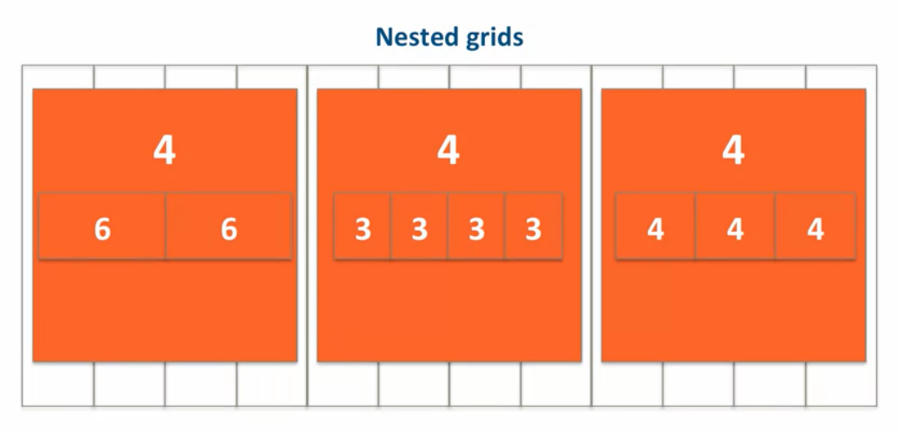

\**For responsive layouts include Viewport meta tag to turn off mobile phone zooming,*

***<meta name="viewport" content="width=device-width, initial-scale=1">***

*It tells the browser(mobile phone) to consider the width of content as device width itself, and not to zoom out or zoom in.(By default mobile browsers load websites in zoomed out 0.4 scale)*

*Eg.* Example code given in lecture 24 under examples.

***INTRDUCTION TO TWITTER BOOTSTRAP***

**What is Bootstrap?**

Bootstrap is the most popular HTML, CSS, and JavaScript framework for developing responsive, mobile first projects on the web.

It is mainly a CSS framework.

-bootstrap.js depends on jquery (So jquery needs to be downloaded)

**THE BOOTSTRAP GRID SYSTEM**

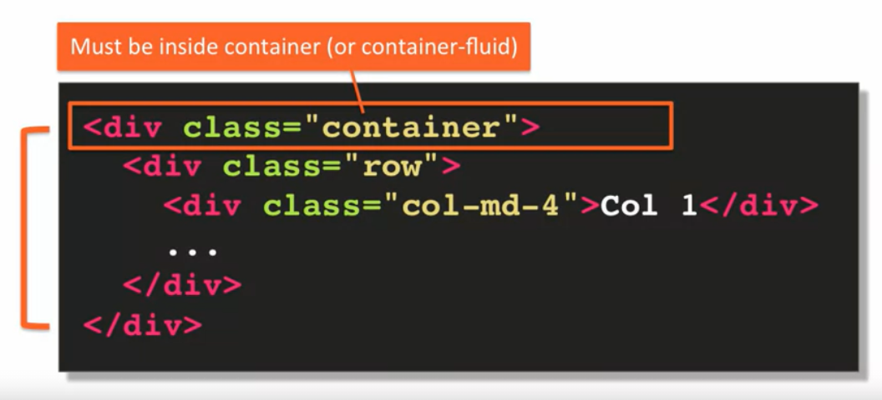

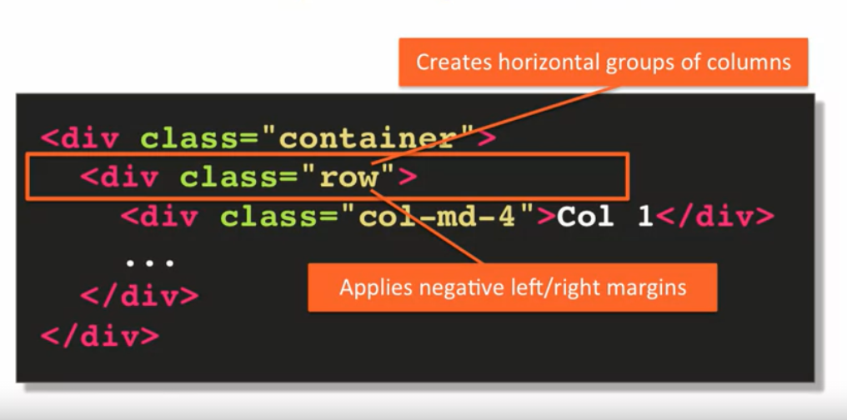

Why NEGATIVE MARGIN in row?

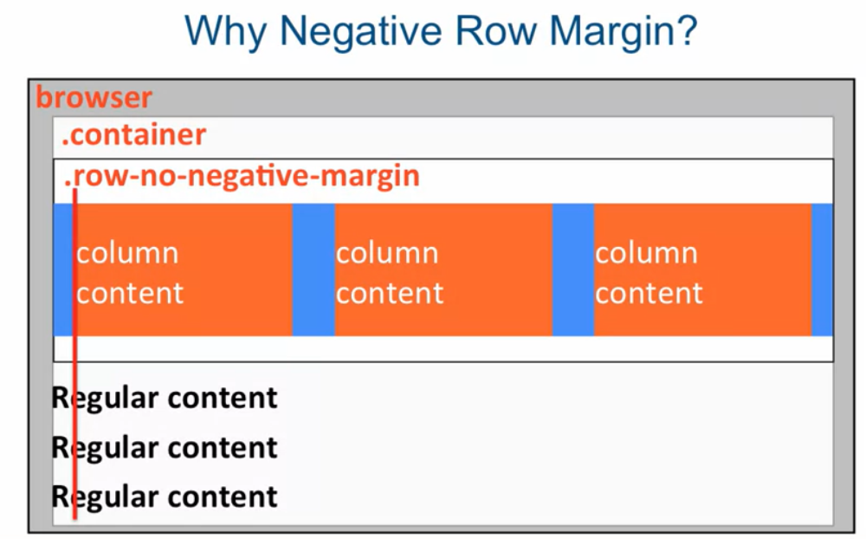

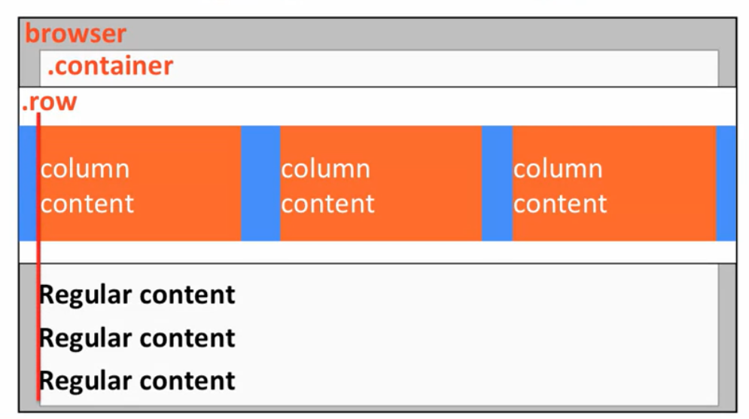

Having consistently aligned edges of different content structures is basic principle. And bootstrap implements this design principle by applying negative row margin.

Every good website does it. If its not done then ur eye tells u something is wrong.

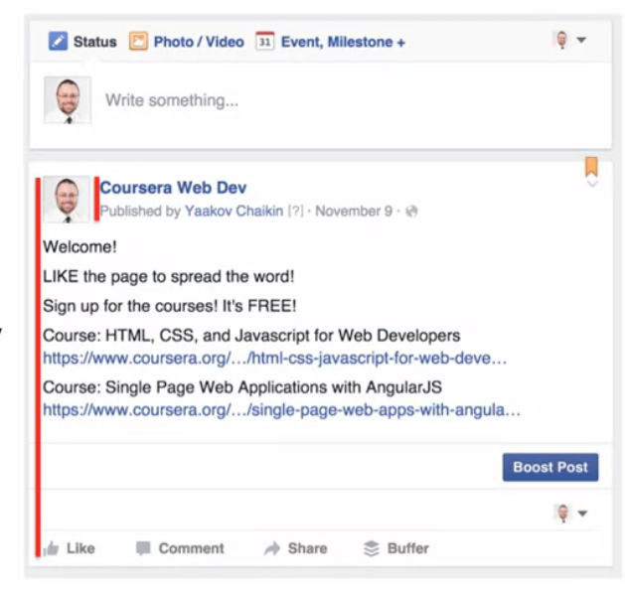

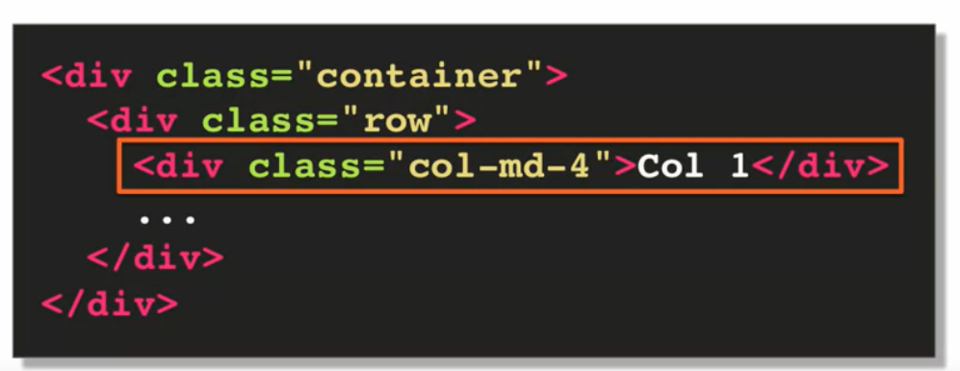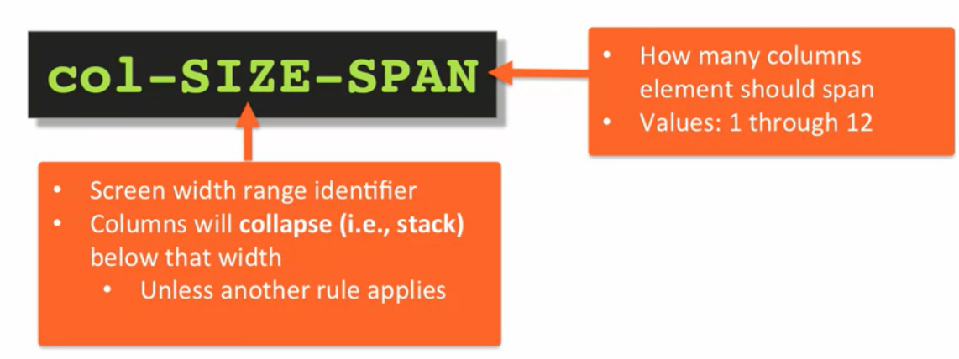

Another example:

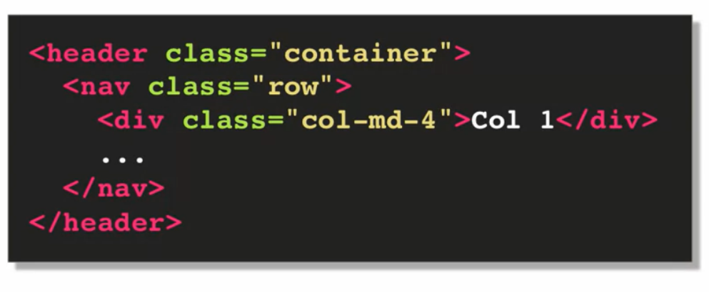

** If we want our layout to never change with respect to screen size we can use ‘xs’ for extra small, “col-xs-SPAN”. (its defined in bootstrap like that i.e. not to change)

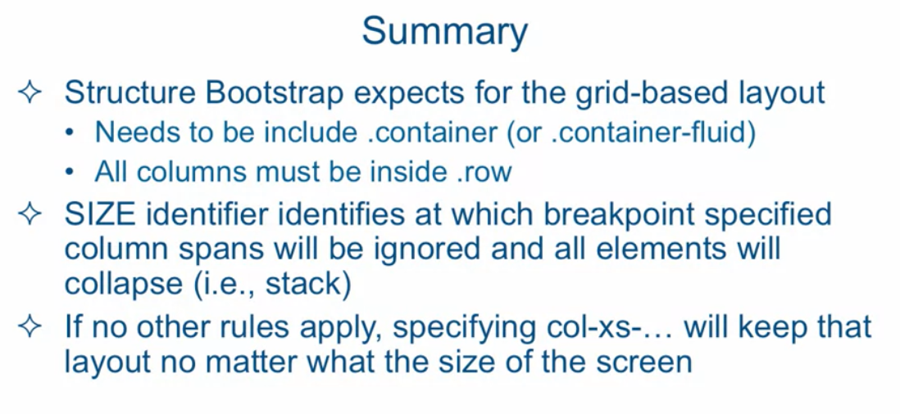

<link rel="stylesheet" href="css/bootstrap.min.css">

<link rel="stylesheet" href="css/styles.css"> *//Our styles in case we want to make any modifications to bootstrap styles.*

<!-- jQuery (Bootstrap JS plugins depend on it) -->

<script src="js/jquery-2.1.4.min.js"></script>

<script src="js/bootstrap.min.js"></script>

<script src="js/script.js"></script> //*Our javascript*

***VISIT THE CLIENT***

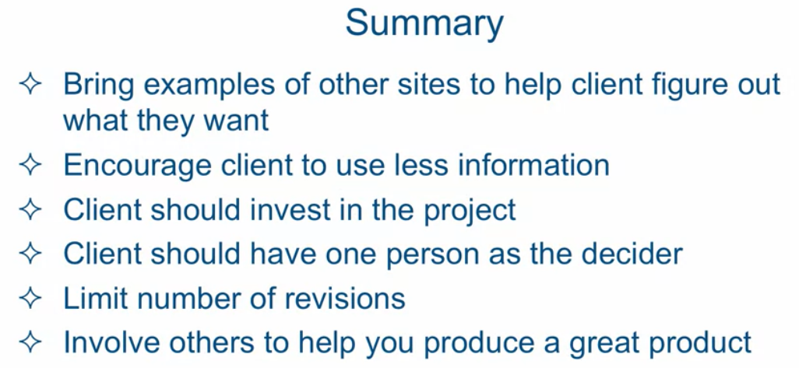

**Design Overview**

“So when you're first starting to design a website,

the worst thing you could possibly do is start coding right away.

You don't want to do that.

You don't want to design a website coding it at the same time.

What you do want to do is you want to have some mock ups, some layout mock ups,

that you present to the client that take little to no time to design and

to put together and present to the client.

And once they approve, and you know exactly what you're coding,

of what you're trying to strive for then you turn to the code editor and

you start coding the website.”

*Use google fonts for free fonts.

**CODING BASICS OF NAVBAR**

Navbar stands for navigation bar.

-Implemented using <nav> element.

Some Bootstrap classes are “ navbar navbar-default” ,One is base class and is subclass that adds some properties to it.

Border-radius : is the property that defines the roundness of the corners.

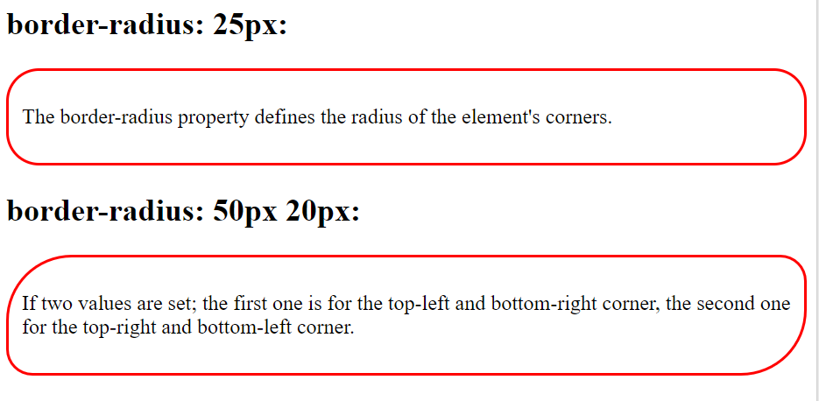

**pull-left** :Is a bootstrap class for floating the element to left.

Eg. <a href=”index.html” class = “pull-left”>

**visible-md**: This class of bootstrap tells that , the element should be allowed to be visible for medium screen devices.

Similarly we have **visible-lg.**

Eg. When we are fighting for screen realestate in small devices we can omit an element,

*<div id=”logo-img” alt=”Logo Image” class=”pull-felt visible-md visible-lg”>*

The class 'container-fluid' stretches to the full width of the browser window (minus some margins) and automatically adjusts its width as you change the width of the browser.

*Whereas class ’container’ will keep the content width fixed for specified until specified breakpont.*

*[https://stackoverflow.com/questions/22262311/container-fluid-vs-container#:~:text=container%2Dfluid%20expands%20to%20fill%20the%20available%20width.&text=Depending%20on%20the%20width%20of,div%20a%20specific%20fixed%20width.&text=container%2Dfluid%20element%2C%20on%20the,changes%20to%20your%20browser%20width](https://stackoverflow.com/questions/22262311/container-fluid-vs-container" \l ":~:text=container-fluid expands to fill the available width.&text=Depending on the width of,div a specific fixed width.&text=container-fluid element%2C on the,changes to your browser width).*

**hidden-xs**: Is a bootstrap class that tells that , hide this element when screen size is extra small.

The following code will trigger the phone to call that number,

<a href="**tel:410-602-5008**">

<span>410-602-5008</span></a>

**<br> tag :** The HTML <br> element produces a line break in text (carriage-return). It is useful for writing a poem or an address, where the division of lines is significant.

**vw font-sizing**: Its a responsive font-sizing unit. vw stands for viewport width.

1vw = 1% of viewport width.

Eg: font-sizing: 1vw;

-One way to load a different size image depending on the browser width is to use 'background-image' CSS property and load a different 'url' in different media queries.

-- placeholder.it : website that we can use if we don’t have images for the webpage at the moment, it will reserve space like real image.

**To put map in webpage,** go to google maps, search for the location.

Go to “share or embed map” option under the side menu bar.

Copy the location link for opening the location in google maps.

Copy the <iframe> thing for image of map location.

Adjust the height and width as required in the <iframe>.

*for making an element a**utomatically centered** ,

*“We can just specify the left and right margin as auto.”*

Works only if sizing is applied (height and width) for that element.

<hr> : this tag is used to give horizontal rule or line ;)

<footer></footer>: html tag used for footer.

Class: panel-footer -> Bootstrap class for footer.

Q).What Bootstrap class would you use in order to show an element on the page ONLY if the width of the browser window was below 768px (extra small or xs)?

Ans: visible-xs

Bootstrap classes for text align,etc : https://getbootstrap.com/docs/4.0/utilities/text/

If content of a section/part in a layout sticks out.. maybe due to long text,etc and layout gets disturbed and ugly, we use “clearfix” bootstrap class.

**JAVASCRIPT**

Declaring variables:

No types are declared,

since JavaScript is dynamically typed language.

That also means that same variable can hold different types of data(string, int ,etc) during execution.

Functions:

Syntax:

1). function *functionName* ( ) {...}

2). var *functionName* = function ( ) {...}

**Note that in second syntax, value of function is assigned NOT the returned vale!**

Function Call OR Function Invocation:

*functionName* ( );

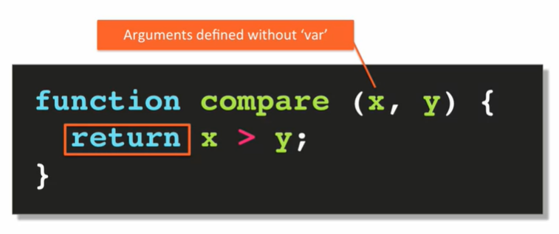

Function Arguements:

**All arguements defined inside javaScript function are optional.**

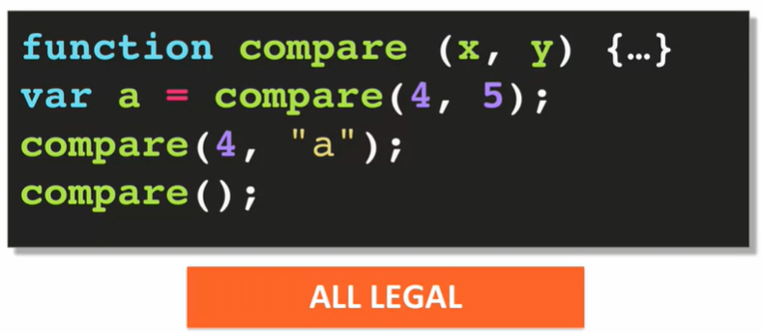

**We can define functions inside other functions.**

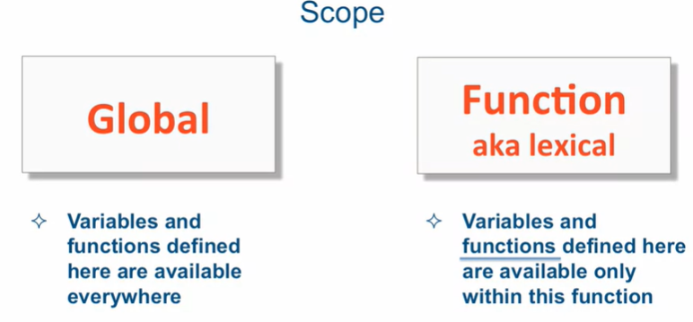

**Scope Chain**

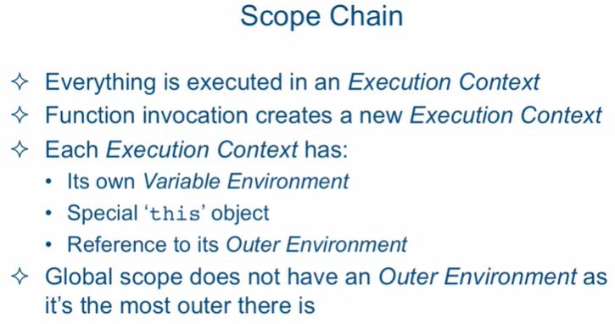

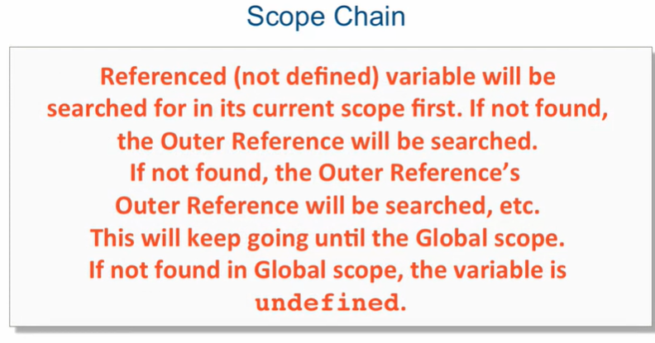

Suppose functions A() and B() is defined globally, and we have line of code as follows:

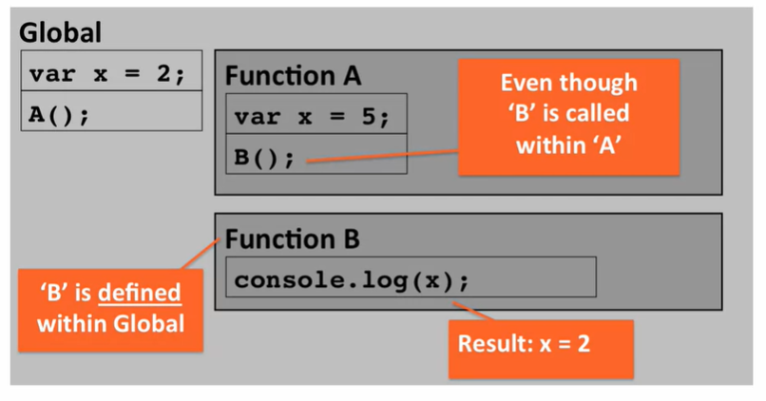

**Identify valid Javascript code snippet(s):**

(i). var x = "Hello world!";

Correct

Regular variable declaration.

(ii).var x = function () {

console.log("Hello World");

return;

};

Correct

It's valid. The 'return' statement here doesn't do much as the function will return anyway without it.

(iii).var x = function () {

console.log("Hello World");

return;

};

x();

Correct

Valid. The last line simply executes/invokes the function.

(iv). var x = function () {

console.log("Hello World");

return;

};

x = "hello, I am a new value!";

Correct

Valid. Javascript has dynamic typing, so 'x' can be a function and then can change to be a regular string.

(v). var x = function ()

[

console.log("Hello World");

return;

];

Incorrect, since function body should be within curly braces.

**Data Types in JavaScript**

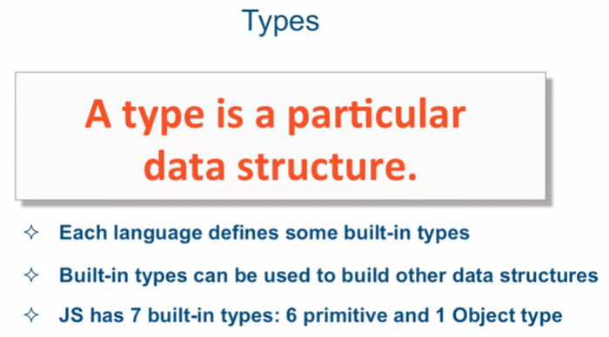

**What is an Object in JavaScript?**

Object in javascript is nothing more than a collection of name-value pairs.

We can have 1 name-value pair, can also have 0 name value pair.

We can also have nested objects.

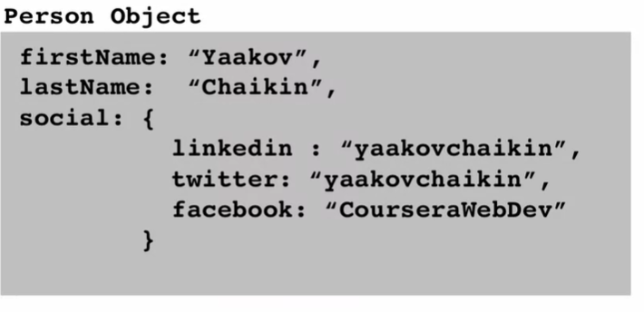Eg:

**Primitive Types**

Have single value, i.e. NOT an object (since object have name-value pairs).

**6 Primitive Data Types:**

1. Boolean

2.Undefined : No value has been set, but variable is declared.

We should not explicitly assign undefined to a variable, as it creates confusion.

3.Null : Value assigned is null.

As opposed to undefined null can be explicitly assigned to a variable, without any confusion.

4.Number : Its the only numeric data type in JavaScript.

Always represented under the hood as **double-precision 64-bit**

**floating point**( that means 4 bytes).

-JS does not have a separate **integer** type, its subset of Number.

5.String : Single or double quotes can be used to define string.

Also back tick can be used , to write strings in sexy way.

6.Symbol : (defined in ES6)

**Common Language Constructs**

-String concatenation can be done using plus (+) operator.

-Precedence of parentheses is applied.

-NaN property represents Not a Number value.

**Equality(==):**

JavaScript automatically converts the datatypes to match and then checks for equality.

Ex:

var x = “4” , y = 4;

if (x == y) {

console.log("x='4' is equal to y=4");

}

***Output: x=’4’ is equal to y=4***

If we don’t want automatic type conversion during equality check, then we can use **strict equality.**

**Strict Equality(===** and **!==):**

This equlity comparision will NOT do automatic type conversion, if the data types don’t match it will give false output directly (maybe doesn’t even compare).

Ex:

var x = “4” , y = 4;

if (x === y) {

console.log("Strict: x='4' is equal to y=4");

}

else {

console

.log("Strict: x='4' is NOT equal to y=4");

}

***Output: Strict: x='4' is NOT equal to y=4***

**Stuff that will give false in JavaScript:**

// ***** If statement (all false)

if ( **false || null ||**

**undefined || "" || 0 || NaN**) {

console.log("This line won't ever execute");

}

else {

console.log ("All false");

}

**Stuff that will give true in JavaScript:**

/ ***** If statement (all true)

if (**true && "hello" && 1 && -1 && "false"**) {

console.log("All true");

}

***JavaScript has a wrapper object for all primitive types,***

*for boolean we have* ***Boolean(),*** *that can be used to check booloean output of anything.*

*Eg:* ***Boolean(“”);*** // Output: false

**Several Ways of handling Default Values in Function Parameters:**

1.

function orderChickenWith(sideDish) {

if(sideDish === undefined)

{

sideDish = “whatever!”;

}

console.log("Chicken with " + sideDish);

}

orderChickenWith("noodles");

orderChickenWith();

2.

function orderChickenWith(sideDish) {

**sideDish = sideDish || "whatever!";**

console.log("Chicken with " + sideDish);

}

orderChickenWith("noodles");

orderChickenWith();

3.

function orderChickenWith(sideDish = "whatever") {

console.log("Chicken with " + sideDish);

}

orderChickenWith("noodles");

orderChickenWith();

***\*When we use OR (||) operator, as soon as it encounters a true value, it stops checking further right values, and returns true as output.***

Eg:

*Given the following Javascript code:*

var x = 10;

if ( (null) || (console.log("Hello")) || x > 5 ) {

console.log("Hello");

}

*How many times will the word 'Hello' be printed to the console?*

1

3

2

0

Correct ans : 2

Since we are using an OR operator, the 'if' statement will stop evaluating conditions after it encounters the very first clause that evaluates to true.

null is false, so we continue

console.log("Hello"), prints "Hello" to the console and returns nothing, so it's 'undefined' and 'undefined' is false, so we continue

x > 5 is true, so we execute the body of the 'if' statement and print another "Hello".

So, the answer is that "Hello" will be printed to the console 2 times.

***\*In JavaScript variable and function name can start with $,***

***eg:* let $stock = 110;**

**Creating Objects Using ‘new Object()’:**

Syntax:

**let** *objectName* **=** **new Object();**

*objectName.proberty1* ***=*** *value1;*

*objectName.proberty2* ***=*** *value2;*

*.*

*.*

*//object inside object*

*objectName.insideObjectName* **= new Object();**

*objectName.insideObjectName.property = value;*

*Eg:*

*var company = new Object();*

*company.name = "Facebook";*

*company.ceo = new Object();*

*company.ceo.firstName = "Mark";*

*company.ceo.favColor = "blue";*

*console.log(company);*

*console.log("Company CEO name is: "*

*+ company.ceo.firstName);*

//**we can also use [] other than ‘.’**

*console.log(company["name"]);* //same as company.name

*var stockPropName = "stock of company";*

*company[stockPropName] = 110;*

*console.log("Stock price is: " +*

*company[stockPropName]);*

**Better Way of Creating Objects:**

*// Better way: object literal*

*var facebook = {*

*name: "Facebook",*

*ceo: {*

*firstName: "Mark",*

*favColor: "blue"*

*},*

*"stock of company": 110* // coz we wanted space in b/w thats why *};* // we are using “”

**Functions**

Functions in JavaScript are known as **1st class data types** i.e. whatever we can do with variables, we can also do it with functions.

You could pass that around, assign it to a variable,

you could pass it as an argument to another function,

you could return it as a return result from a function.

**Functions in JavaScript are objects.** We can create properties for functions like objects.

Eg:

function multiply(x, y) {

return x * y;

}

multiply.version = "v.1.0.0";

console.log(multiply.version);

**We can return a function from another function**,

Eg:

// Function factory

function makeMultiplier(multiplier) {

var myFunc = function (x) {

return multiplier * x;

};

return myFunc;

}

var multiplyBy3 = makeMultiplier(3);

console.log(multiplyBy3(10));

var doubleAll = makeMultiplier(2);

console.log(doubleAll(100));

**We can pass functions as an argument to another function,**

Eg:

// Passing functions as arguments

function doOperationOn(x, operation) {

return operation(x);

}

var result = doOperationOn(5, multiplyBy3); **//*multiplyBy3 is function* //*reference ,***

**//*multiplyBy3( ) is function call***

console.log(result);

result = doOperationOn(100, doubleAll);

console.log(result);

------------------------------------------------------------------------------------------------------------------------

***We can implement radio button, checkbox, date input, time input , date and time input using <input> tag in html.***

***In order for radio button to work , it should be under same name.***

***------------------------------------------------------------------------------------------***

**Passing Varibles By Value VS By Reference**

In JavaScript ***primitive datatypes*** are passed/copied by **value** , and ***objects*** are passed/copied by **reference.**

-Actually “under the hood”, everything is passed by value.

-The difference comes by how they are stored in memory.

Let’s see how it works under the hood:

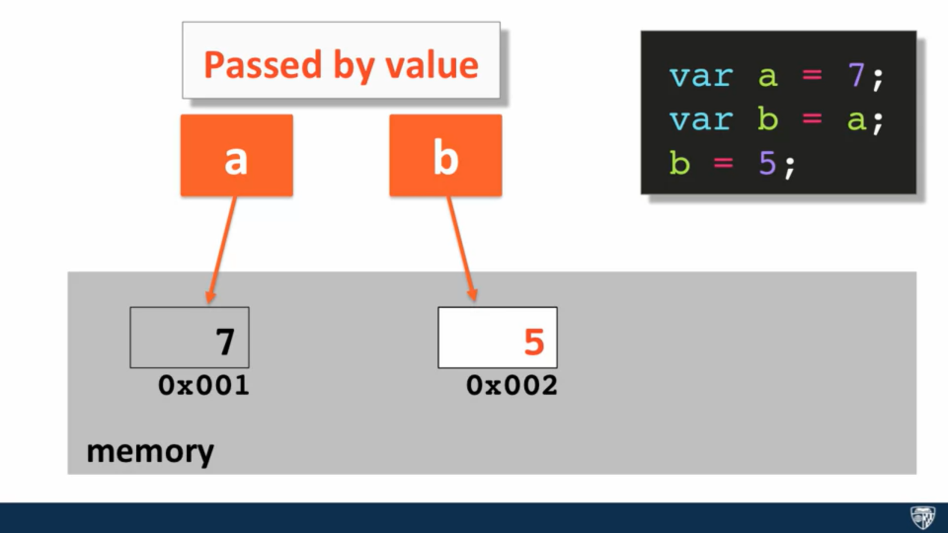

Here we can see that for primitive variables its normally stored in memory , hence its copied by value when copied to another varible, only the content is copied.

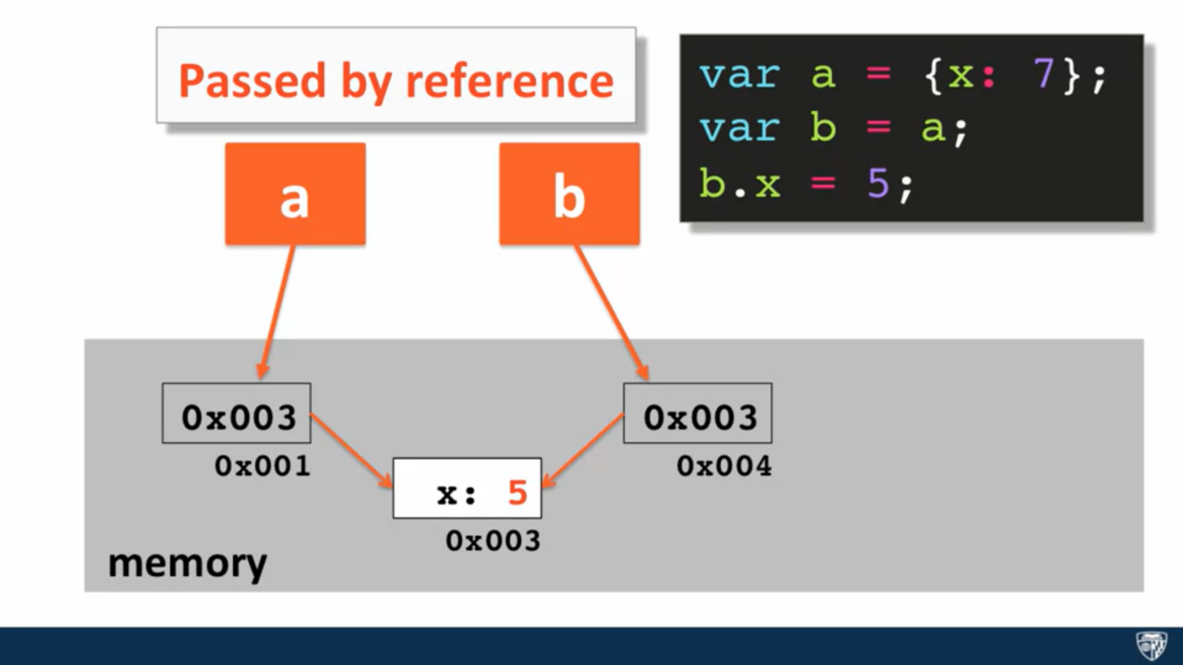

For objects we can see that , at the address of the object, there is address of the labels stored, hence when equated to another variable, the address of labels is copied, thereby achieving copying by **reference.**

(Actually its a simplified version of what happens, but something like this only happens in case of objects)

**Similarly** as we saw for copying , **passing** also works the same way , as we are assigning value to function parameter through argument, as we do in a = b, same thing.

**FUNCTION CONSTRUCTORS:**

**or *NEW WAY OF CREATING OBJECTS:***

In practice function objects, begin with a capital letter.

- Function constructors cannot return anything.

By default this points to the global ‘window’ object, but inside objects it points to the object.

-Function constructors are like blueprint for the objects that we want to create (similar to classes).

Must read:

https://www.w3schools.com/js/js_object_constructors.asp

https://www.w3schools.com/js/js_object_prototypes.asp

Eg:

--------------------------------------------------------------------------

function Circle (radius) {

this.radius = radius;

console.log(this);

}

Circle.prototype.getArea =

function () {

return Math.PI * Math.pow(this.radius, 2);

};

var myCircle = new Circle(10);

console.log(myCircle.getArea());

-------------------------------------------------------------------------

-Whenever we create an object using function constructor, using the ‘new’ keyword an object gets created having same name as of the function constructor, and is assigned to the variable on LHS.

**Object Prototype:**

All JavaScript objects inherit properties and methods from a prototype.

Object prototype is used to add properties and methods to function constructors:

Eg:

function Person(first, last, age, eyecolor) {  
 this.firstName = first;  
 this.lastName = last;  
 this.age = age;  
 this.eyeColor = eyecolor;  
}  
  
Person.prototype.name = function() {  
 return this.firstName +" "+this.lastName;  
};

Person.prototype.nationality = "English";

**Object literals and ‘this’:**

Inside normal functions ‘this’ points to gobal window object.

***Whereas,***

Inside a function that is inside an object, ‘this’ points to the object in which the function is written.

**Bug in JavaScript implementation:**

When we define a function inside another function that is inside an object, ‘this’ in the inner function ***instead of pointing to the containing object POINTS TO GLOBAL WINDOW OBJECT.***

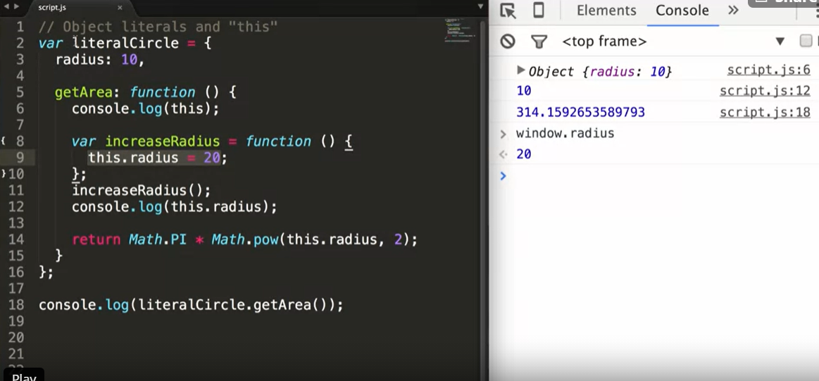**Solution:**

*We can have another variable pointing to the containing object.*

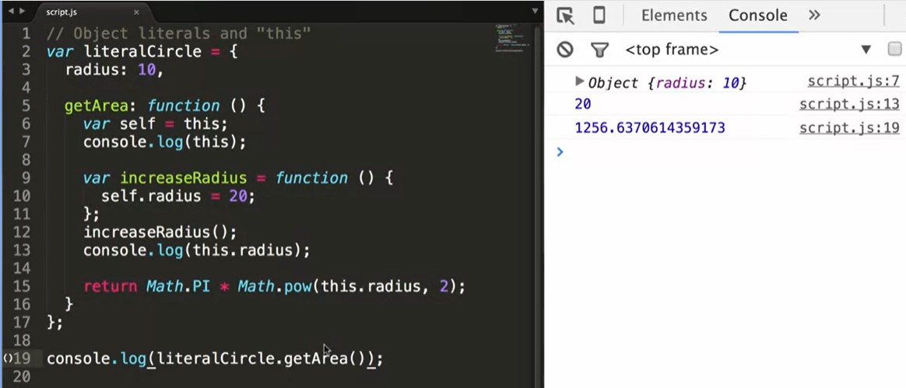*This bug is supposedly fixed in ES6.*

*-------------------------------------------------------------------------------*